727721EUIT152
SOMA SUNDARI R
DAY 7
TASK 1:
package com.demo.demo;

import org.openqa.selenium.WebDriver;
import org.openqa.selenium.chrome.ChromeDriver;
import org.openqa.selenium.chrome.ChromeOptions;
import org.testng.Assert;
import org.testng.annotations.Test;

import io.github.bonigarcia.wdm.WebDriverManager;

public class Day7_01 {
@Test
public void f() {
WebDriverManager.chromedriver().setup();
ChromeOptions co=new ChromeOptions();
co.addArguments("--remote-allow-origins=*");
WebDriver driver=new ChromeDriver(co);
driver.get("https://demo.wpeverest.com/user-registration/guest-registration-form/");
driver.manage().window().maximize();
String actual=driver.getTitle();
String expected="Guest Registration Form – User Registration";
Assert.assertEquals(actual,expected);
}
}
OUTPUT:
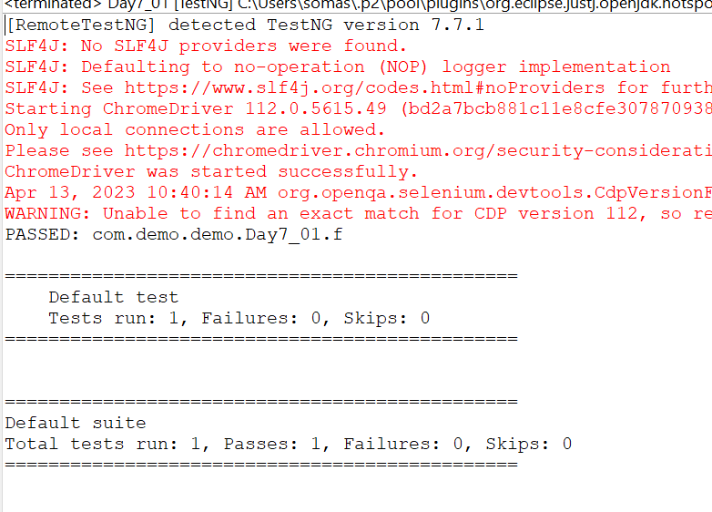
TASK 2:
package com.demo.demo;

import org.testng.Assert;
import org.testng.annotations.Test;

public class Calculator {
@Test
public void add() {
int num1=10;
int num2=20;
int result=num1+num2;
Assert.assertEquals(result,30);
}
@Test
public void sub() {
int num1=20;
int num2=10;
int result=num1-num2;
Assert.assertEquals(result,10);
}
@Test
public void mul() {
int num1=10;
int num2=20;
int result=num1*num2;
Assert.assertEquals(result,200);
}
@Test
public void div() {
int num1=20;
int num2=5;
int result=num1/num2;
Assert.assertEquals(result,4);
}
}
OUTPUT:
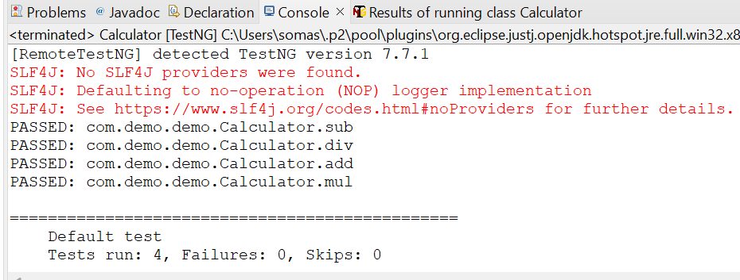
TASK 3:
package com.demo.demo;

import org.testng.annotations.Test;

import io.github.bonigarcia.wdm.WebDriverManager;

import org.testng.annotations.BeforeMethod;
import org.openqa.selenium.By;
import org.openqa.selenium.WebDriver;
import org.openqa.selenium.WebElement;
import org.openqa.selenium.chrome.ChromeDriver;
import org.openqa.selenium.chrome.ChromeOptions;
import org.testng.Assert;
import org.testng.annotations.AfterMethod;

public class Day7_03 {
WebDriver driver;
@Test
public void max_wid() {

WebElement from=driver.findElement(By.xpath("//*[@id=\"app\"]/div[1]/div/div[1]/div/div[2]/div[2]/form/div[1]/div/div[2]/input"));
from.sendKeys("Admin");
WebElement to=driver.findElement(By.xpath("//*[@id=\"app\"]/div[1]/div/div[1]/div/div[2]/div[2]/form/div[2]/div/div[2]/input"));
to.sendKeys("admin123");
WebElement submitBtn=driver.findElement(By.xpath("//*[@id=\"app\"]/div[1]/div/div[1]/div/div[2]/div[2]/form/div[3]/button"));
submitBtn.click();
String CurrentUrl=driver.getCurrentUrl();
String ExpectedUrl="https://opensource-demo.orangehrmlive.com/web/index.php/dashboard/index";
Assert.assertEquals(CurrentUrl, ExpectedUrl);
}
@BeforeMethod
public void beforeMethod() throws InterruptedException {
WebDriverManager.chromedriver().setup();
ChromeOptions co=new ChromeOptions();
co.addArguments("--remote-allow-origins=*");
driver=new ChromeDriver(co);
driver.get("https://opensource-demo.orangehrmlive.com/web/index.php/auth/login");
driver.manage().window().maximize();
Thread.sleep(3000);
}

@AfterMethod
public void afterMethod() {
driver.close();
}

}
OUTPUT;
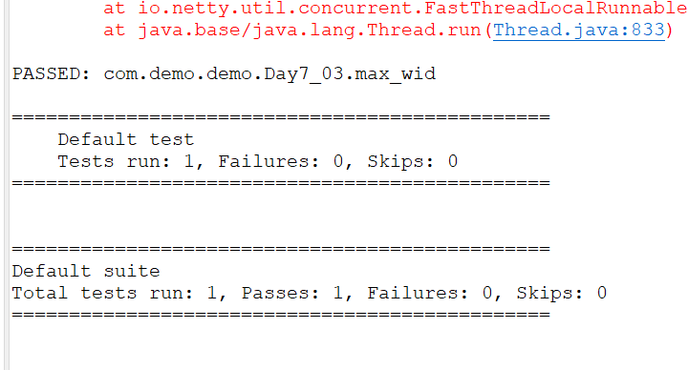
TASK 4:
package com.demo.demo;

import org.openqa.selenium.By;
import org.openqa.selenium.WebDriver;
import org.openqa.selenium.chrome.ChromeDriver;
import org.openqa.selenium.chrome.ChromeOptions;
import org.testng.Assert;
import org.testng.annotations.Test;

import io.github.bonigarcia.wdm.WebDriverManager;

public class Day7_04{
WebDriver driver;
@Test(priority=1)
public void Login() throws InterruptedException {
ChromeOptions co=new ChromeOptions();
co.addArguments("--remote-allow-origins=*");
WebDriverManager.chromedriver().setup();
driver=new ChromeDriver(co);
driver.get("https://opensource-demo.orangehrmlive.com/web/index.php/auth/login");
driver.manage().window().maximize();
Thread.sleep(3000);
driver.findElement(By.xpath("//input[@name='username']")).sendKeys("Admin");
driver.findElement(By.xpath("//input[@name='password']")).sendKeys("admin123");
driver.findElement(By.xpath("//*[@id=\"app\"]/div[1]/div/div[1]/div/div[2]/div[2]/form/div[3]/button")).click();
Assert.assertEquals(driver.getCurrentUrl(),"https://opensource-demo.orangehrmlive.com/web/index.php/dashboard/index");
}

@Test(priority=2, dependsOnMethods=("Login"))
public void Logout() throws InterruptedException {
Thread.sleep(3000);
driver.findElement(By.xpath("//span[@class=\"oxd-userdropdown-tab\"]")).click();
Thread.sleep(3000);
driver.findElement(By.xpath("//ul[@class=\"oxd-dropdown-menu\"]/li[4]/a")).click();

Assert.assertEquals(driver.getCurrentUrl(),"https://opensource-demo.orangehrmlive.com/web/index.php/auth/login");
}

}
OUTPUT:
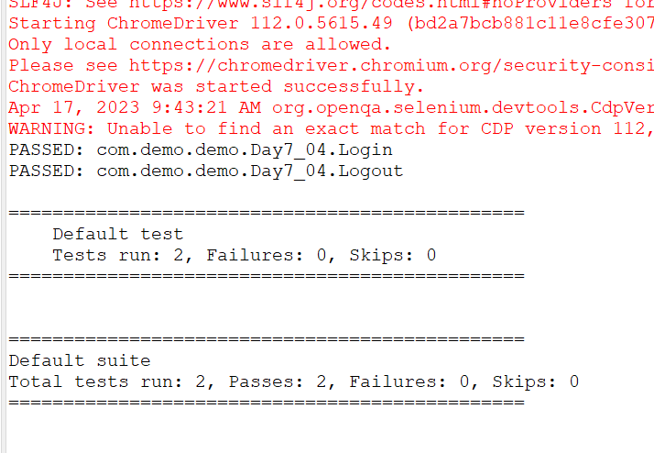

TASK 5:
package com.demo.demo;
import org.testng.annotations.Test;
import io.github.bonigarcia.wdm.WebDriverManager;
import org.testng.annotations.BeforeMethod;
import java.util.concurrent.TimeUnit;
import org.openqa.selenium.By;
import org.openqa.selenium.WebDriver;
import org.openqa.selenium.chrome.ChromeDriver;
import org.openqa.selenium.chrome.ChromeOptions;
import org.testng.Assert;
import org.testng.annotations.AfterMethod;

public class Day7_05
{
WebDriver d;
@Test(groups=&quot;Smoke Test&quot;)
public void t1()
{
String eurl=&quot;https://www.godaddy.com/en-in&quot;;
String curl=d.getCurrentUrl();
Assert.assertEquals(eurl,curl);
String etitle=&quot;Domain Names, Websites, Hosting &amp; Online Marketing Tools - GoDaddy IN&quot;;
String ctitle=d.getTitle();
Assert.assertEquals(etitle,ctitle);
}

@Test(groups=&quot;Regression Test&quot;)
public void t2()
{
d.manage().timeouts().implicitlyWait(10,TimeUnit.SECONDS);

d.findElement(By.xpath(&quot;//*[@id=\&quot;id-631b049a-e9c0-4d24-8710-
c504745206dd\&quot;]/div[2]/div[1]/ul/li[1]/button&quot;)).click();
d.findElement(By.xpath(&quot;//*[@id=\&quot;id-631b049a-e9c0-4d24-8710-
c504745206dd\&quot;]/div[2]/div[1]/ul/li[1]/div/div[2]/div[1]/ul/li[2]/a&quot;)).click();
}

@Test(groups=&quot;Regression Test&quot;)
public void t3()
{
d.manage().timeouts().implicitlyWait(10,TimeUnit.SECONDS);
d.findElement(By.xpath(&quot;//*[@id=\&quot;id-631b049a-e9c0-4d24-8710-
c504745206dd\&quot;]/div[2]/div[1]/ul/li[1]/button&quot;)).click();
d.findElement(By.xpath(&quot;//*[@id=\&quot;id-631b049a-e9c0-4d24-8710-
c504745206dd\&quot;]/div[2]/div[1]/ul/li[1]/div/div[2]/div[1]/ul/li[2]/a&quot;)).click();
String ctitle=d.getTitle();
String etitle=&quot;GoDaddy Domain Search - Buy and Register Available Domain Names&quot;;
System.out.println(ctitle);
Assert.assertEquals(etitle, ctitle);
}

@BeforeMethod
public void beforeMethod()
{
ChromeOptions co=new ChromeOptions();
co.addArguments(&quot;--remote-allow-origins=*&quot;);
WebDriverManager.chromedriver().setup();
d=new ChromeDriver(co);
d.get(&quot;https://www.godaddy.com/en-in&quot);
d.manage().window().maximize();
}

@AfterMethod

public void afterMethod()
{
d.close();
}
}

OUTPUT:
